**Specs Sale details:**

***(NOTE: Create Stored Procedures for all the 3 questions using Sub Queries)***

The below schema has Model details of spectacles along with its sale details.

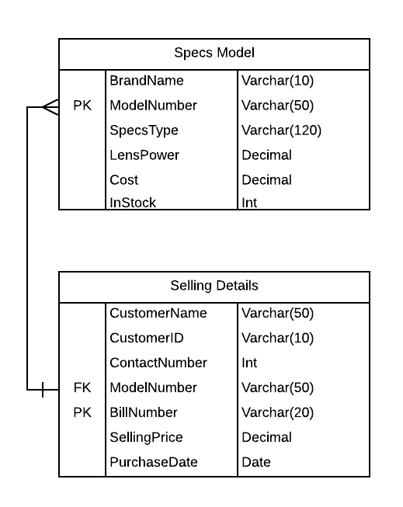

**Queries:**

1.Write a query to select (BrandName, ModelNumber, SpecsType ) for a particular purchase date?

2. Find out For March2020 (as input) select which brand was sold-out maximum along with its count?

3.Write a query to select (Model Name) of our regular customer (Customers who bought more the twice).